***Login***

1. Get (Http Method)- URL



1. Basic authentication. Username and Password

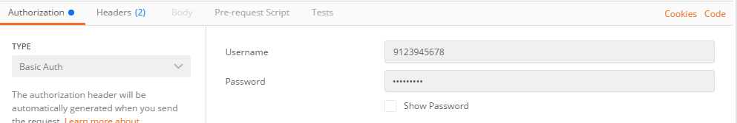

1. Response would be like this.

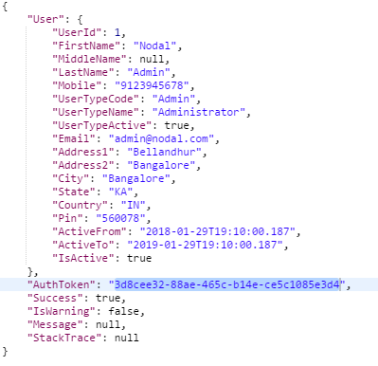

**Order**

1. Post (Http Method) - URL



1. Pass the below “Header” and “Value”

The “AuthToken” would be your value for “Authorization”, this you will get as a response once you make login request (If you are successfully authenticated).



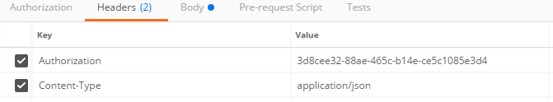

1. Your Order saving object must be formed (HTTP request body) like below.

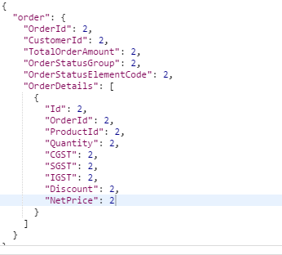

1. On Successful of this post call, you will receive the following response.

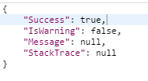

***Note: The above explanation is applicable for Order Create and Update.***

**API Details:**

Create Order API: <http://nodalmobsys.azurewebsites.net//api/Order/Create>

Update Order API: <http://nodalmobsys.azurewebsites.net/api/Order/Update>

Delete Order API: <http://nodalmobsys.azurewebsites.net//api/Order/Delete>

Get Order API: <http://nodalmobsys.azurewebsites.net/api/Order/Get>

Get All Order API: <http://nodalmobsys.azurewebsites.net/api/Order/GetAll>

For More information: Explore <http://nodalmobsys.azurewebsites.net/swagger/ui/index>

***Note:***

If you follow this article you should not be facing any issues during the Api integration/communication.

<https://futurestud.io/tutorials/android-basic-authentication-with-retrofit>